How to Update Supplier Banking:
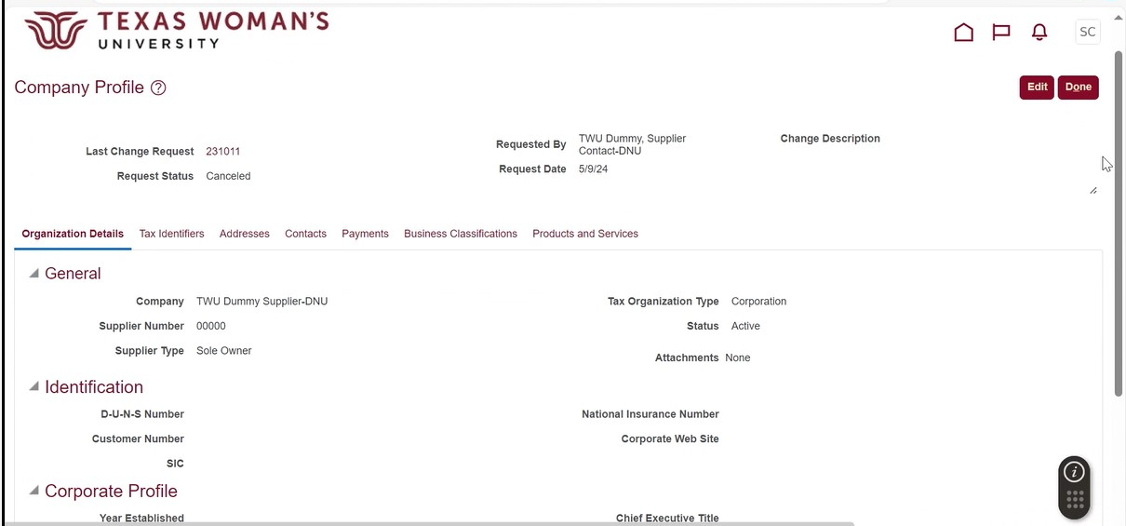
- Open your supplier profile and click “Edit” in the right hand corner.

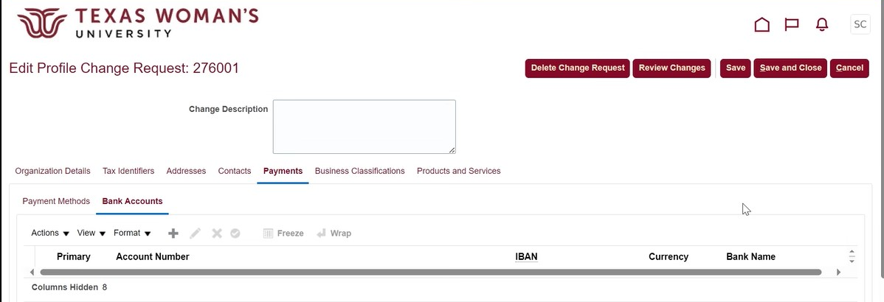
- Go to the “Payments” tab and open the “Bank Accounts” tab. Click the “+” option.

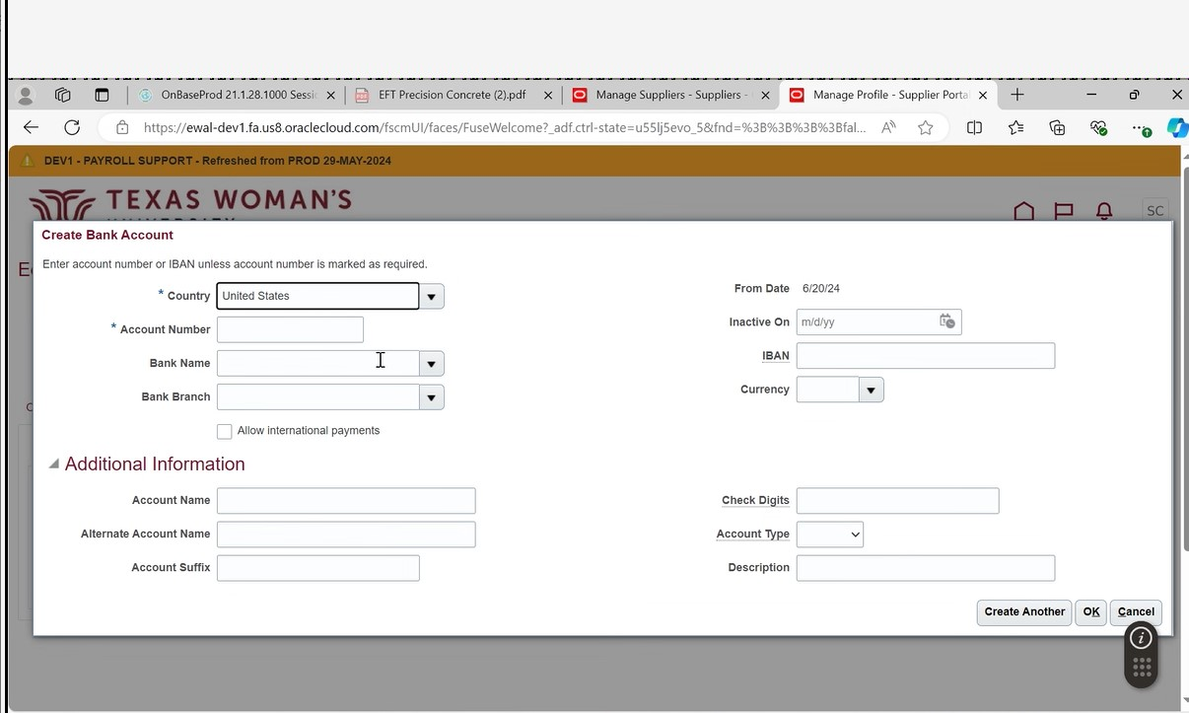
- Begin typing “United States” under the “Country” option. Type slowly and the option will show.
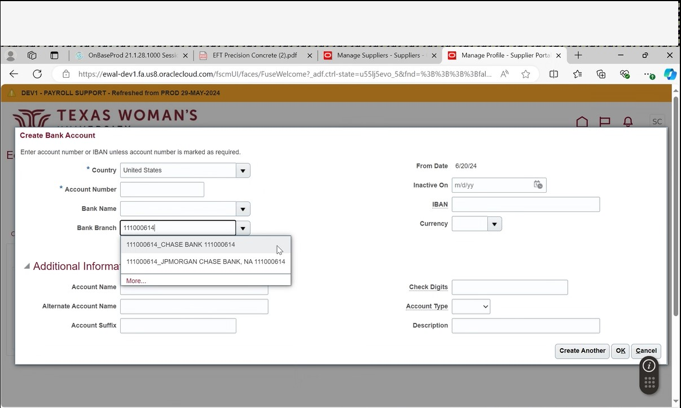
- Enter your bank’s routing number in the “Bank Branch” field. Click the corresponding option from the drop down menu and the “Bank Name” should auto-populate. NOTE: if your routing number is not found please email TWUSupplier@twu.edu to have it added.

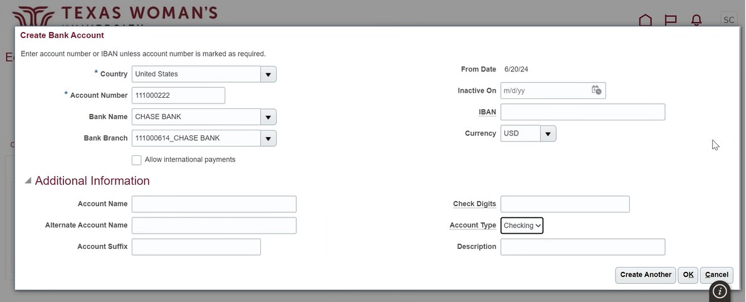
- Enter your account number, choose “USD” currency, and choose your account type. Click “OK” when finished. Note: You don’t need to fill out all the available fields you see below. Those that are filled out are the only required fields.

- Click “Submit”.
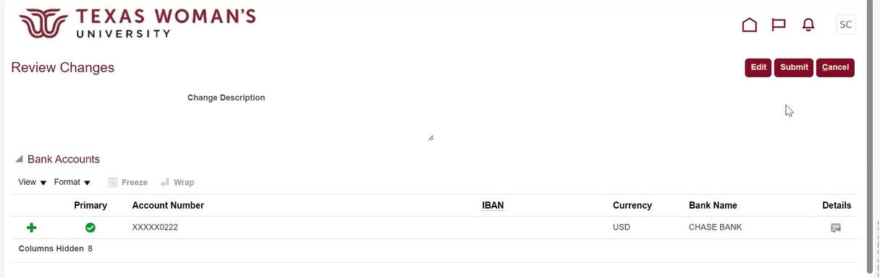
- You’re all done! Your change request will be sent to Procurement for approval. Once we review your banking information it will be approved and finalized. You can click “Done” and exit.
