How to Respond to a Negotiation in Oracle Cloud Supplier Portal

Get Started
- Click the Home icon.

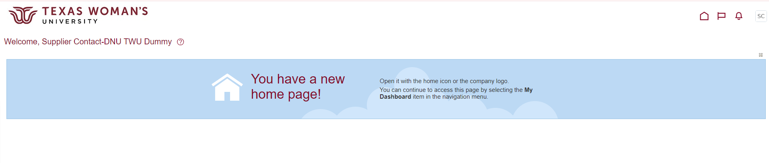

- Select the Supplier Portal tile.
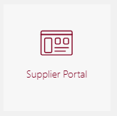

- On the left side of the screen, select View Active Negotiations.

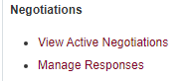
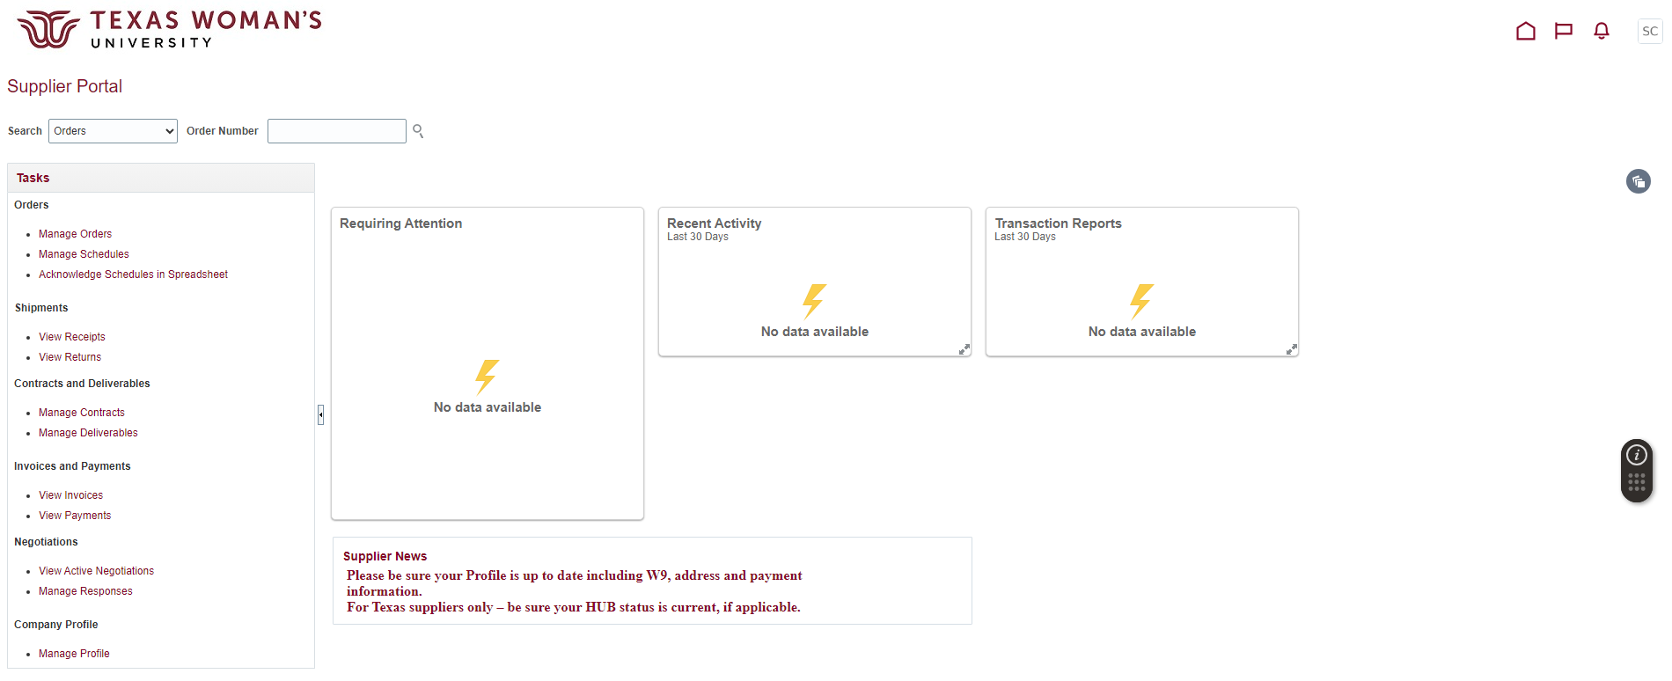

- Toggle Invitation Received to No. Then click Search.
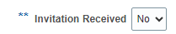
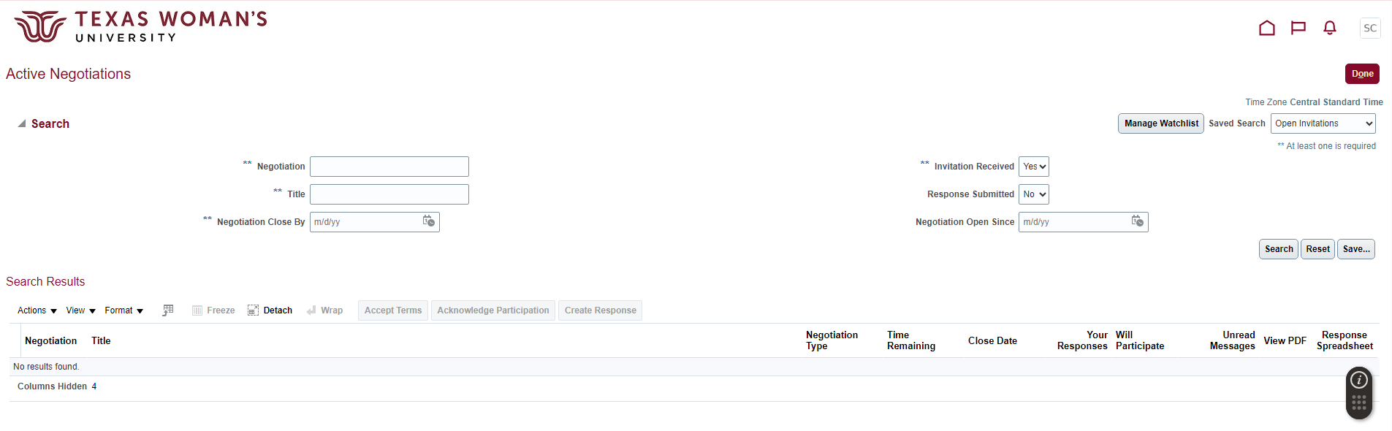

- Click the Negotiation number (in maroon).
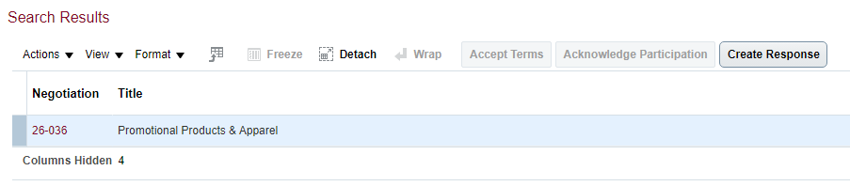

- In the upper right corner, click the Create Response button.


Respond to the Negotiation
- In the Overview section, click Next. (Nothing needs to change on this page.)
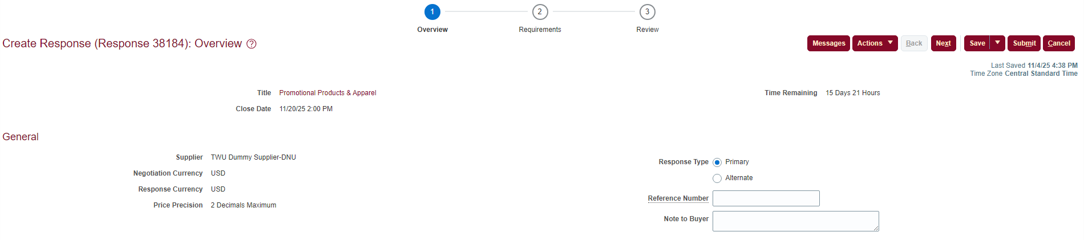

- Under Section 1. Requirements and Criteria, type in your company name followed by “ – Proposal”. Next to Response Attachments, click the Add icon .
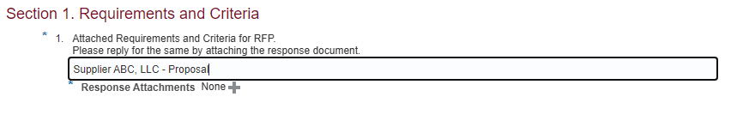

- Click the Add icon to add your attachments. These should include your Proposal file, W9, and any other files that were requested for this solicitation.
Select Choose File and add your attachments one at a time, clicking the Add icon for each attachment.
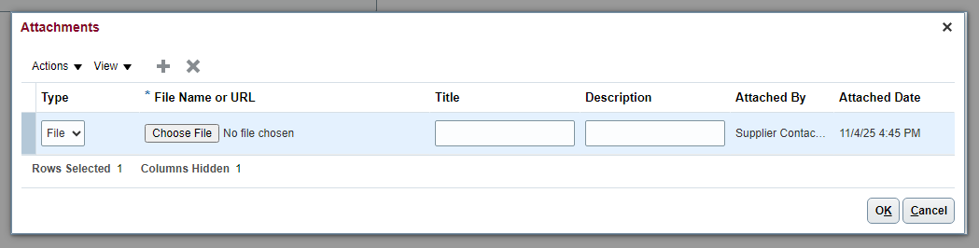

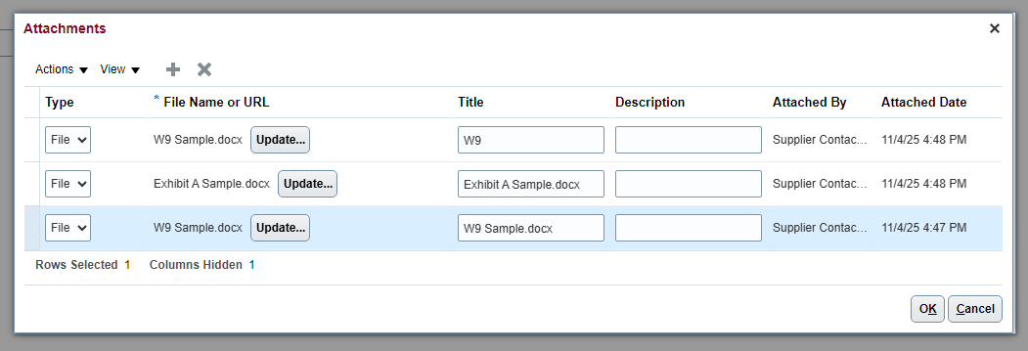

Proposal.docx
Proposal
Once all attachments are added, click OK. Then click Next.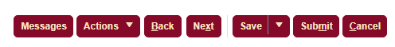

- In the Review section, select the Requirements tab.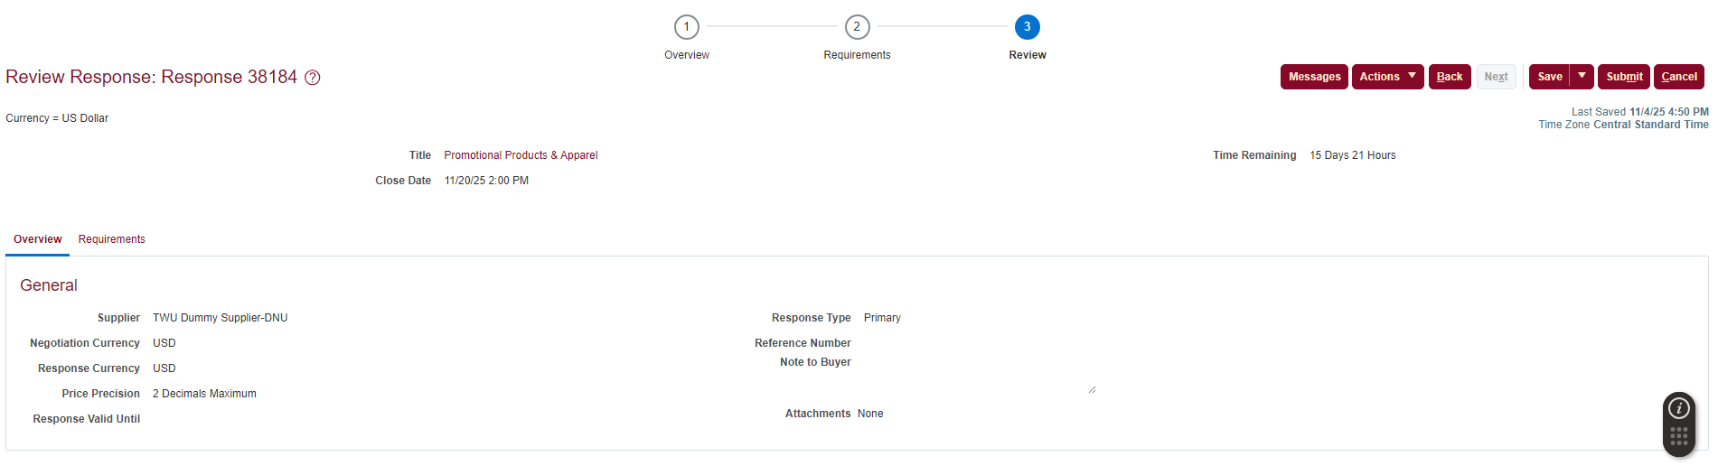


- Click your Response Attachments to verify all files have been attached. Click OK.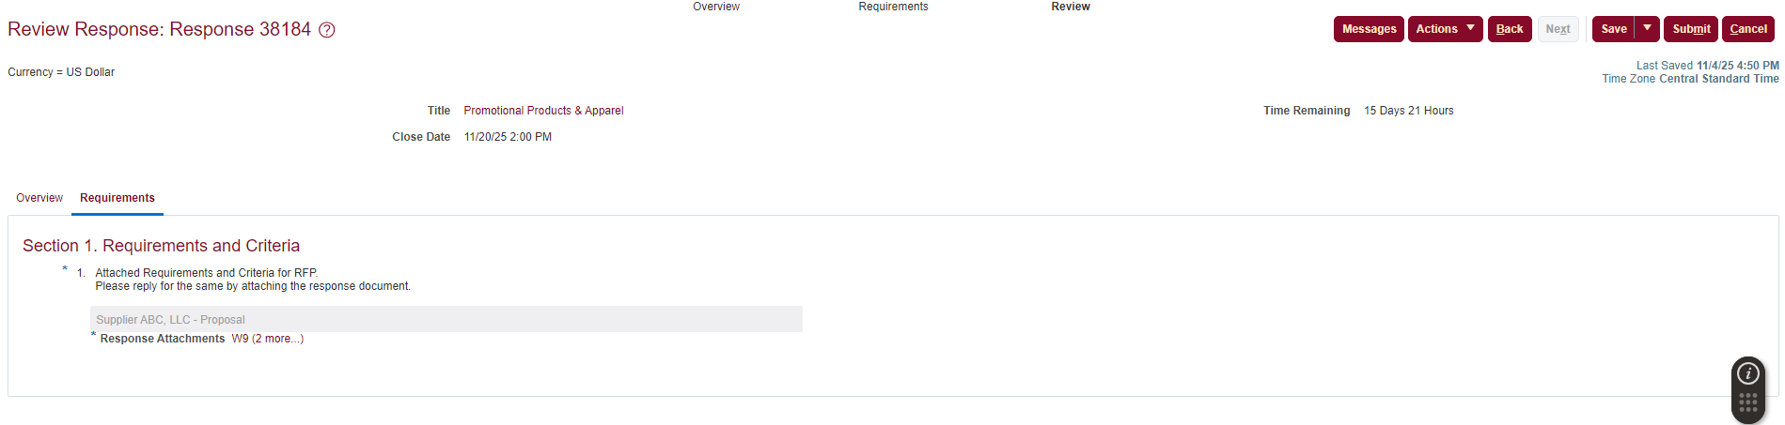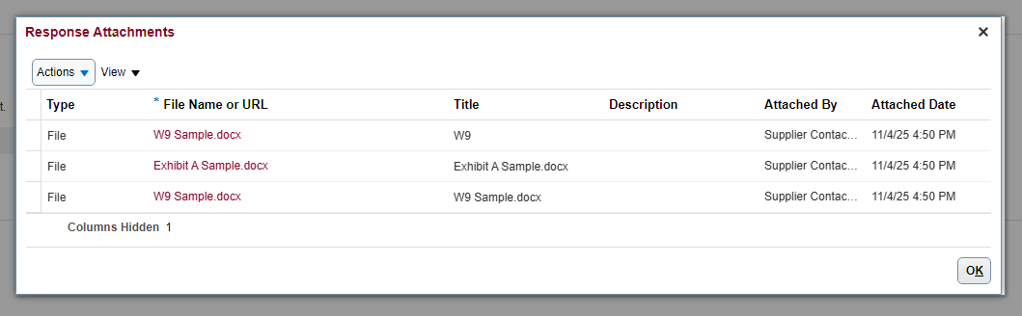
Proposal.docx
Proposal.docx

- Click Submit, and you’re done.

