How to respond to a Negotiation in Oracle Cloud Supplier Portal

- Click Home
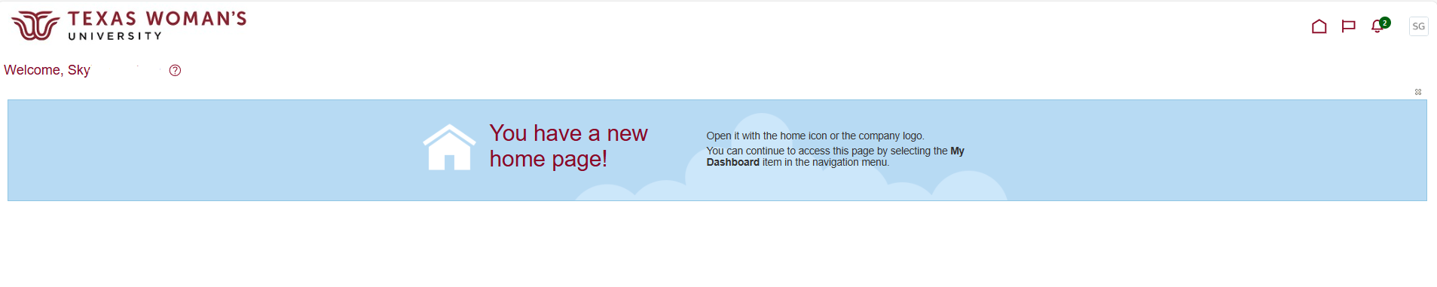

- Click Supplier Portal
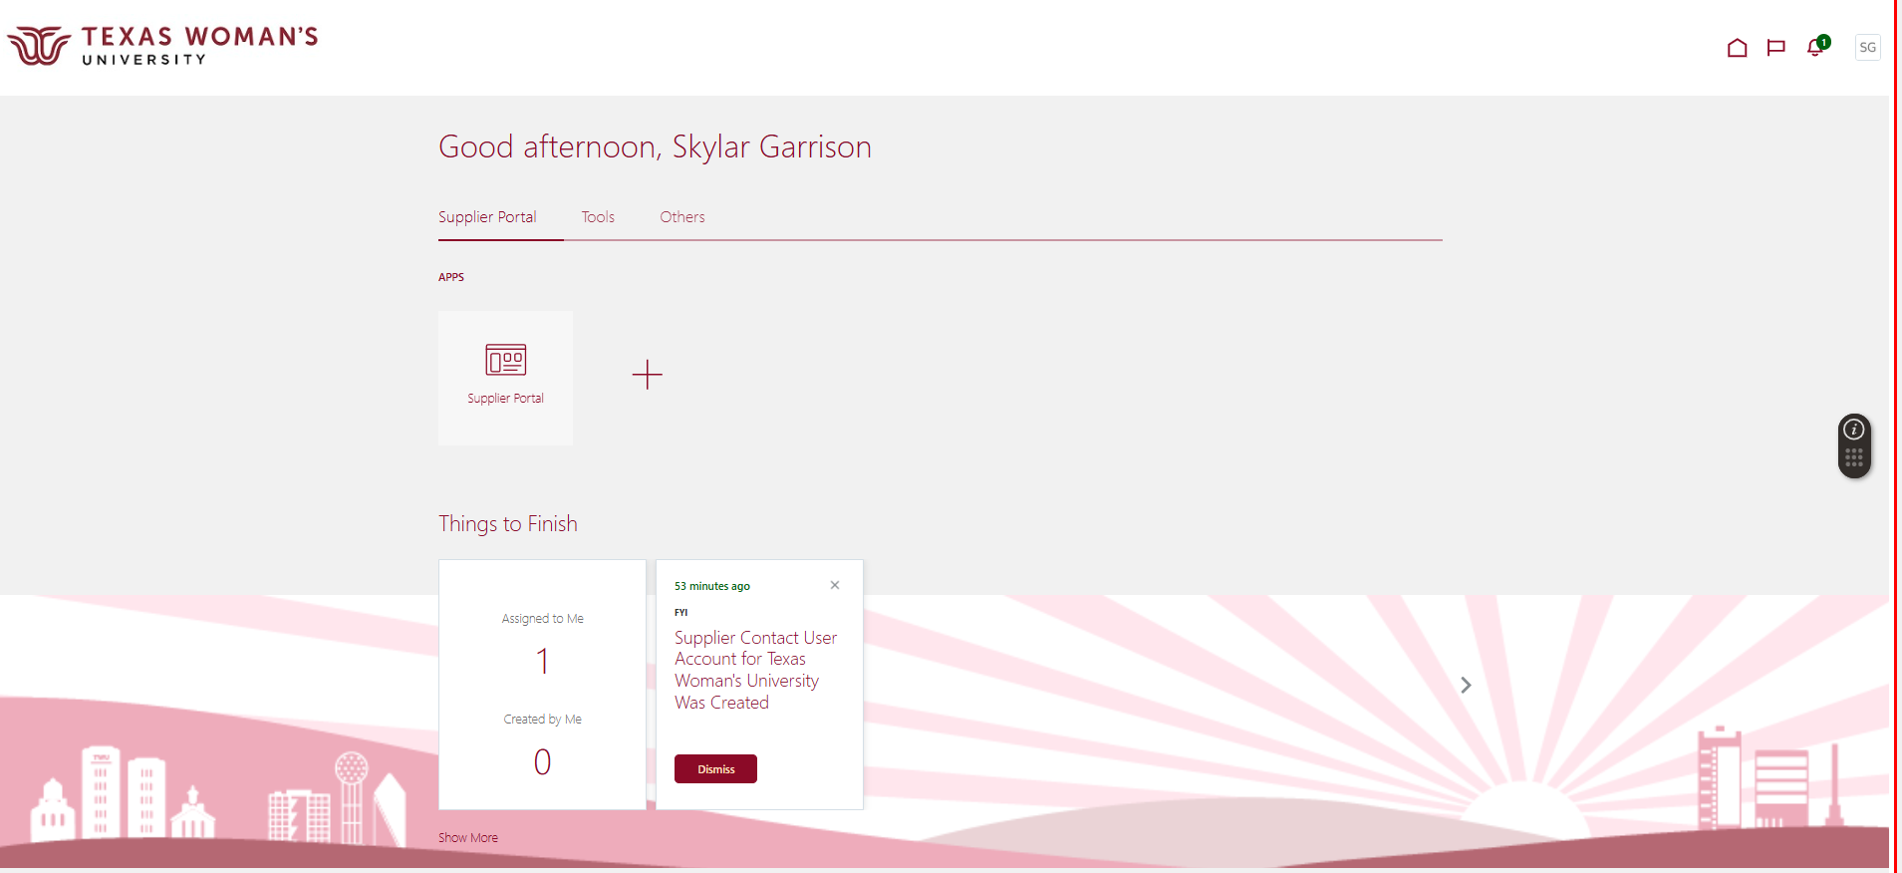

- Click View Active Negotiations
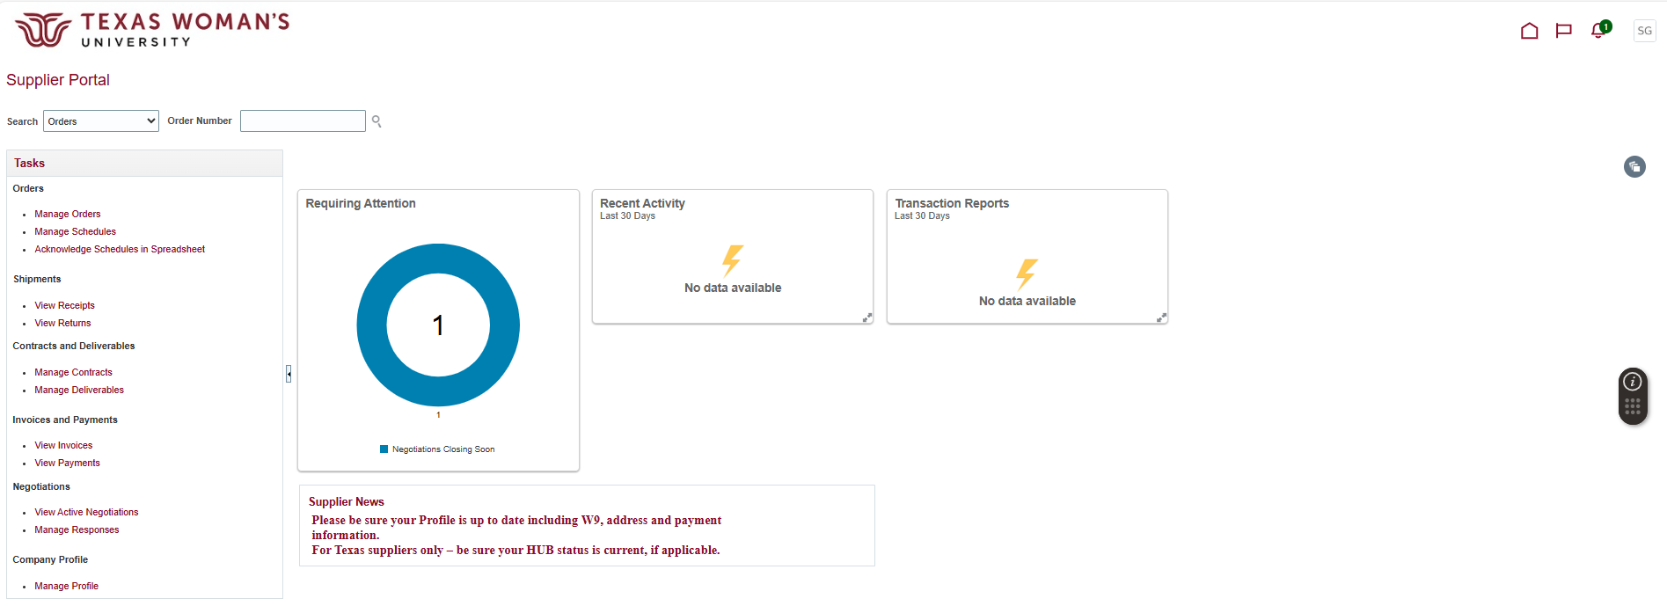

- Change Invitation Received to No
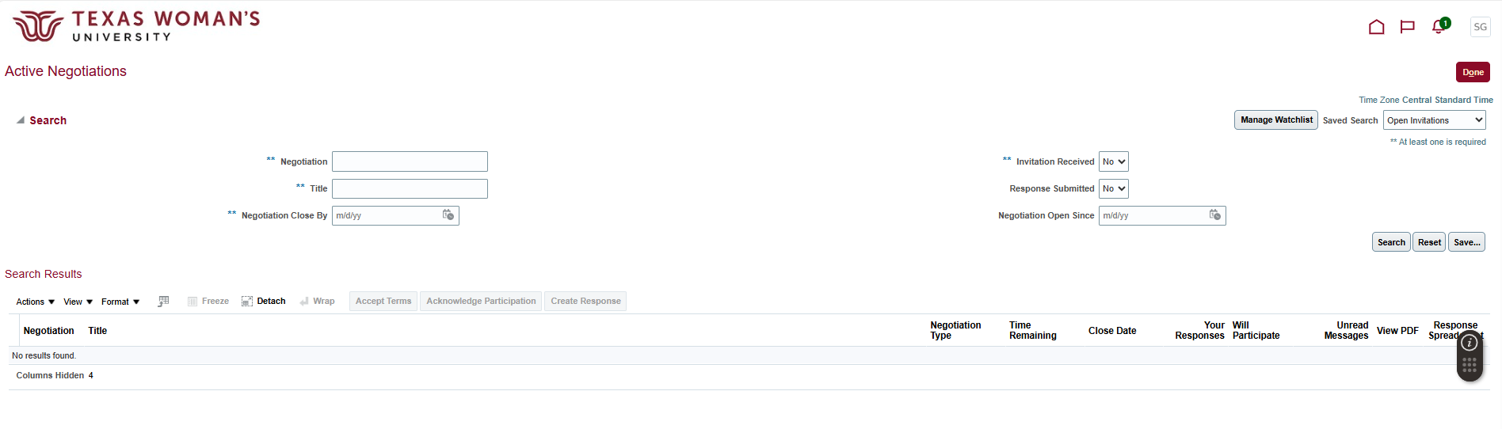

- Click the Negotiation number
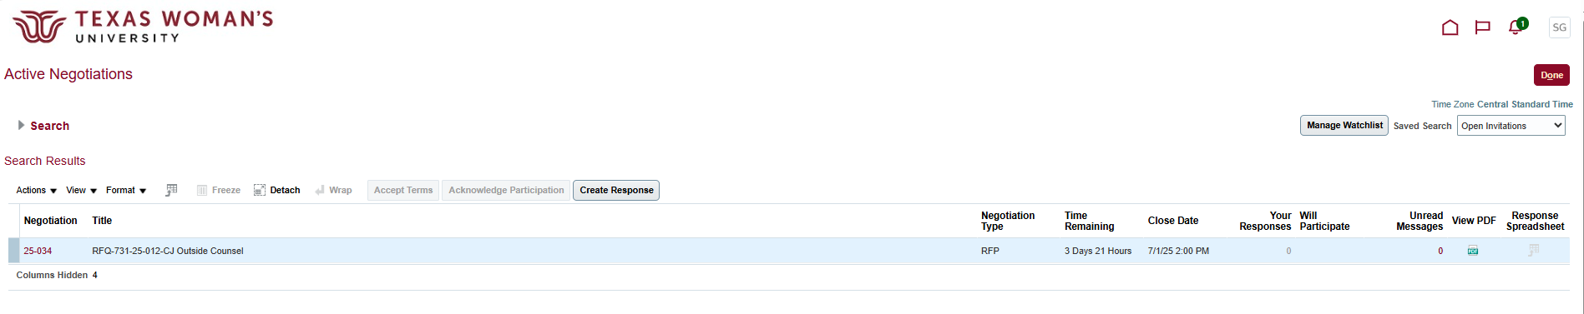

- Click Actions
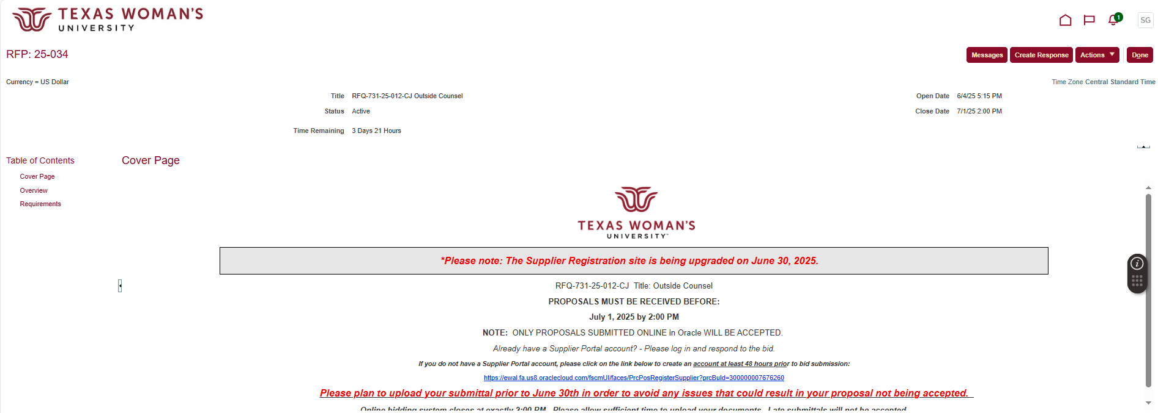

- Click Respond, then click Create Response
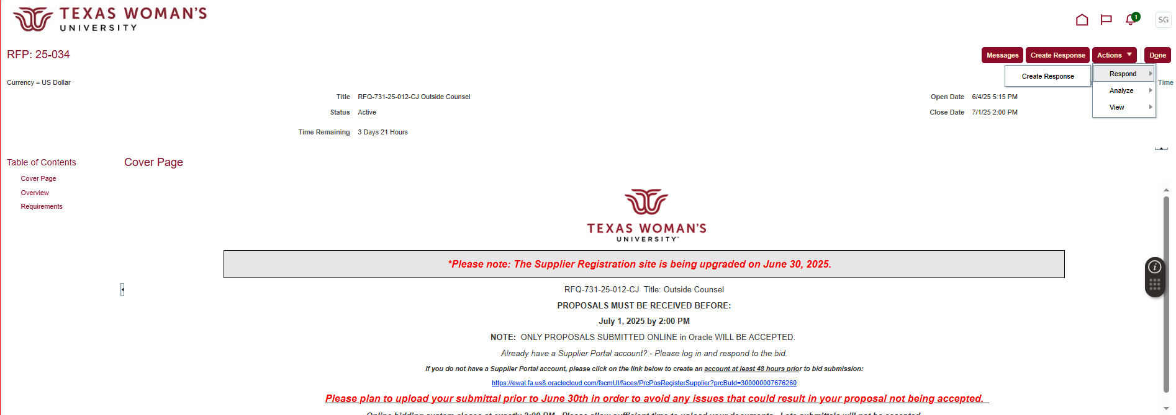

- Click Next (nothing is needed on this page)
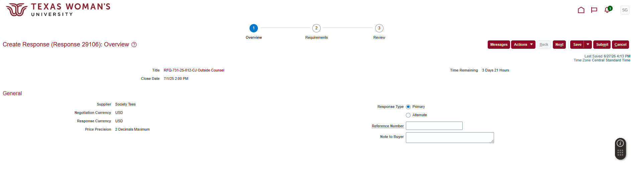
- Add “[Supplier name] – Proposal” in the field above Response Attachments, then click + to add Response Attachments

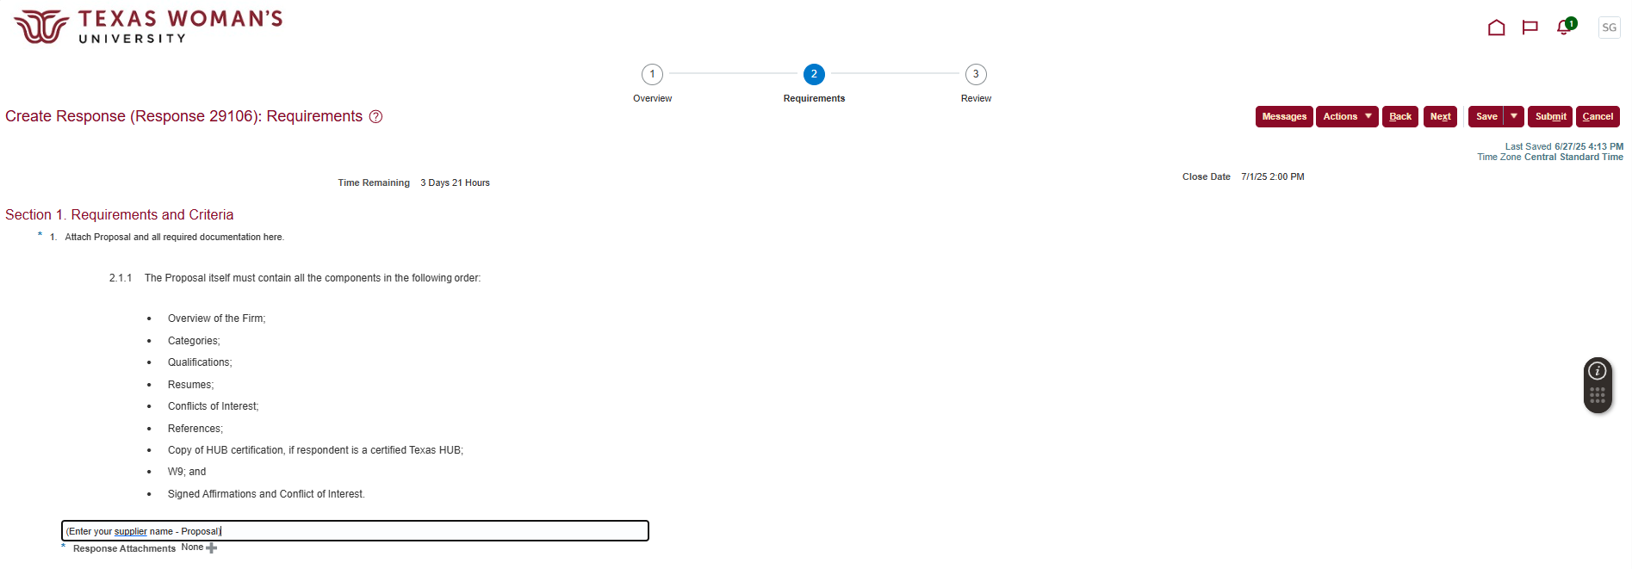

- Click Actions, then click Add
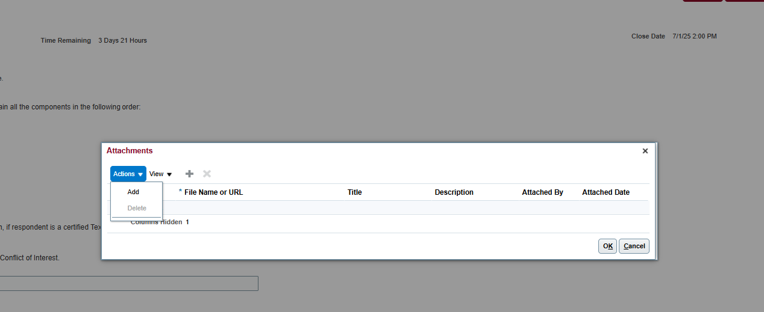

- Click Choose File and add your attachment (if more than one, click + to add additional attachments)
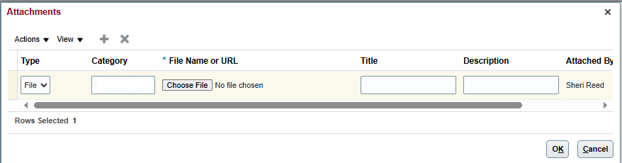

- Click OK, then click Next
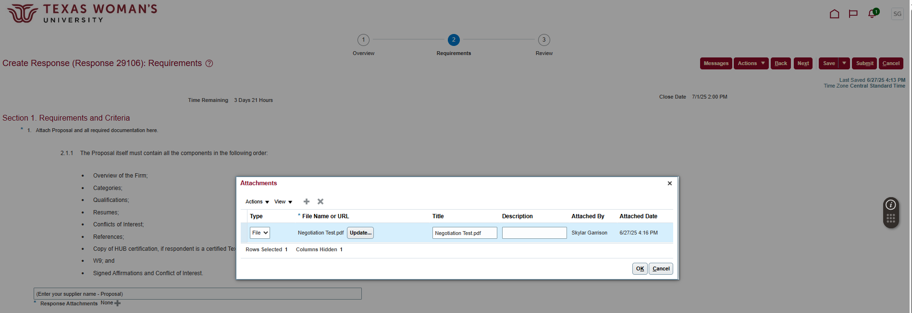

- Verify your attachment link shows at the bottom
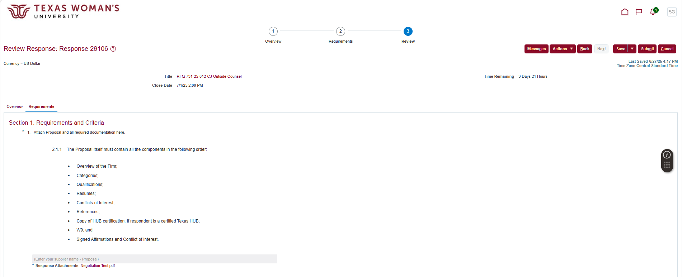

- Click Save, then click Submit

- Your Confirmation will pop up and an email will be sent for your records
