

Supplier Registration Guide

- Access the Supplier Portal via this link: Supplier Registration Link
- Enter Your Email
  - Enter an email that has not been used to register another profile.
  - Retrieve the code you are sent, enter the code, then click “Continue”.

Company Details [1 / 6]

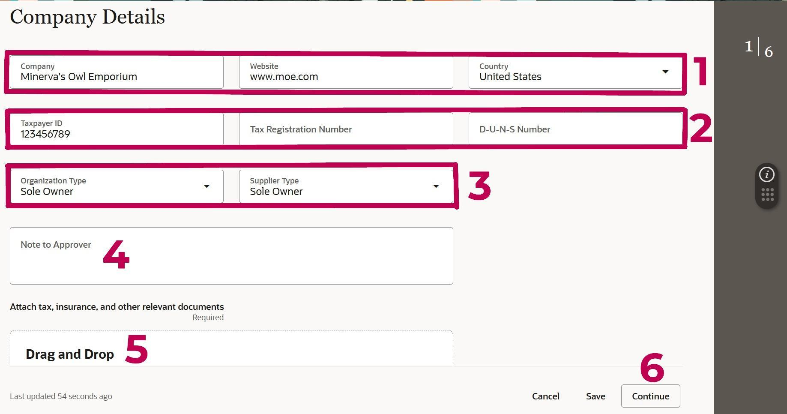

- Start with the company name*, website, and country.
* If you are an Individual, like a guest lecturer, enter your name in this field. If your company is operating under a DBA, enter the DBA Name in this field.
- Enter the country name, the Taxpayer ID or Social Security number listed on your W9. The Tax Registration Number (for non-US companies) will become available. Complete these fields and the DUNS number if applicable.
- Choose the Organization Type and Supplier Type.
  - If you are a TWU student, please choose Supplier type “Student”
  - If you are not a TWU Student, please choose Individual
- Note to Approver
  - If you are registering so you can respond to a bid, indicate the bid # in this field.
  - If you are a TWU student receiving an award or reimbursement, it is important that you let us know in this section.
- Attach a W-9 (W9 MUST be signed and dated within the current year) by clicking on the “Drag and Drop” box.
  - If you are a Texas Certified HUB, attach a copy of your HUB Certification here as well.
- Click “Continue” in the bottom right.

Contacts [2 / 6]

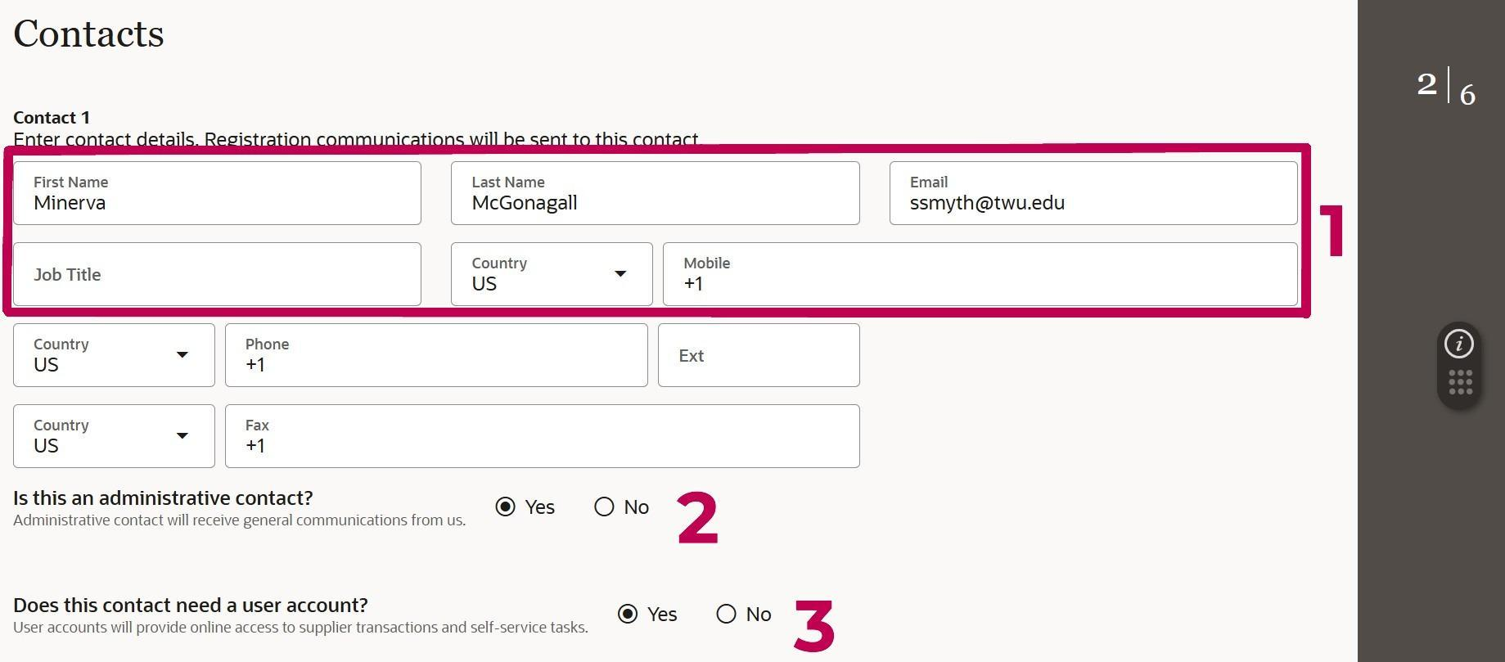

Note: At the bottom of this page, you’ll be able to add additional contacts to this Supplier account.
- Fill in the following fields: Name, Email, and Phone Number.
  - We also recommend including the Job Title and any other phone numbers.
- Choose if this contact will be an administrative contact.
  - Choosing “Yes” will ensure this contact receives general communications from us.
- Choose if this contact will need a user account.
  - Choosing “Yes” will ensure this contact has online access to supplier transactions and self-service tasks.
Note: At least one contact must have a user account, but other contacts can be added just for contact information or to be linked to an address in a later step.

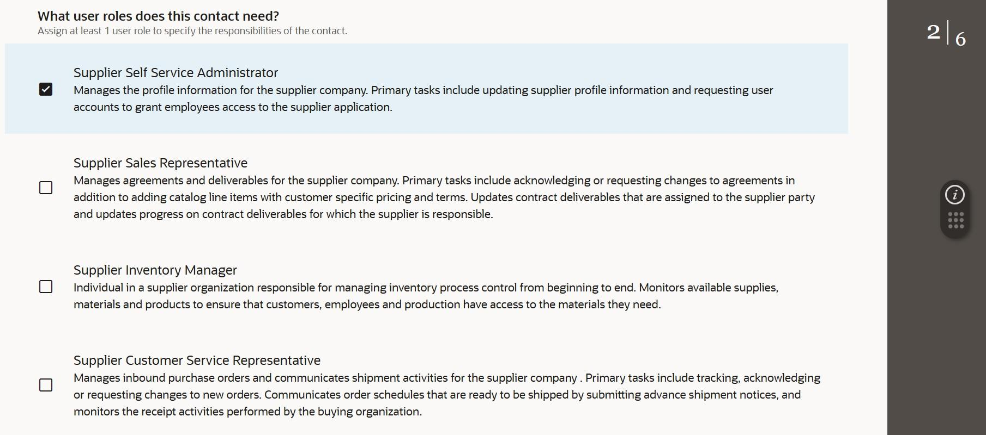
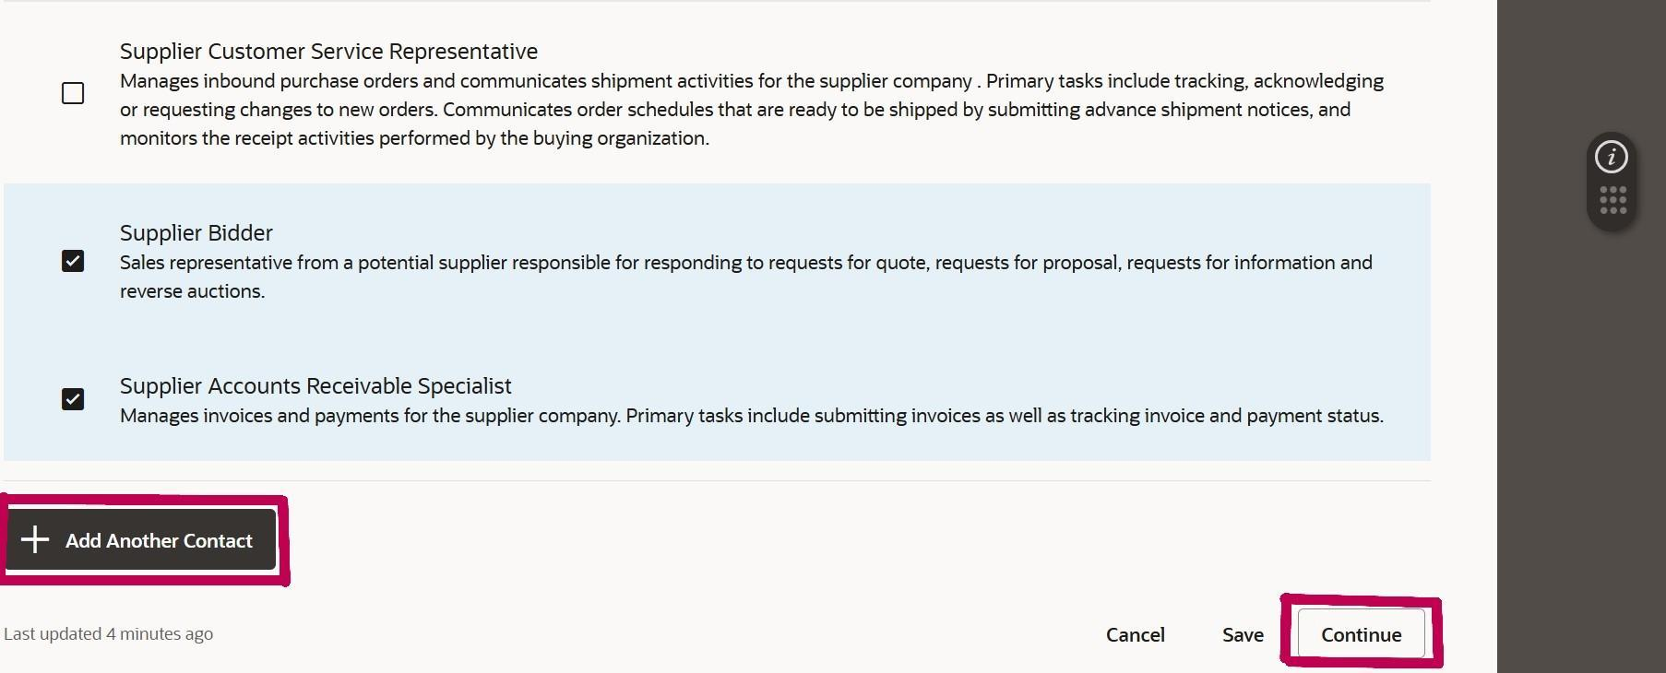

- Scroll down to assign roles to this contact.
- We suggest choosing all the following roles:
  - Supplier Self Service Administrator
  - Supplier Bidder
  - Supplier Accounts Receivable Specialist
  - Any other roles listed that feel applicable to this contact.
- At this point, you may add any additional contacts to this Supplier Account by clicking the button, “Add Another Contact.”
- Once complete, click “Continue”.

Addresses [3 / 6]

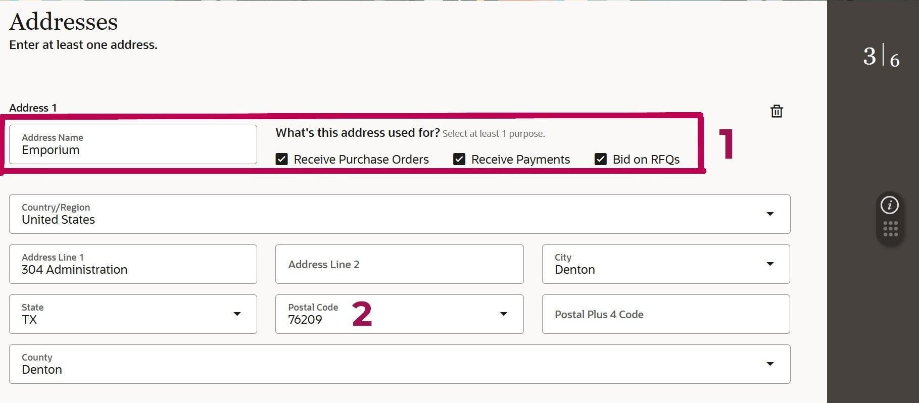

- In the Address Name field, enter the street address (see example below). Check the appropriate box or boxes beside the Address Name - we suggest checking all three boxes.
  - Address Name Example: 123 Main St.
- Next, enter the postal code and then the address lines.
  - Providing the postal code first will auto-populate the city, state, and county.
  - Enter the plus 4 postal code if available.

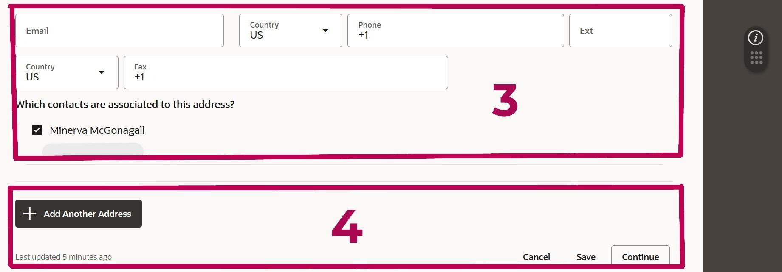

- Provide an email and phone number, then select which contact(s) to link to this address.
- Add another address if desired and click “Continue” when finished.

Business Classifications [4 / 6]

This section only applies to Texas Certified HUBs
If you are not a Texas Certified HUB, click “None of the classifications” and click “Continue”. 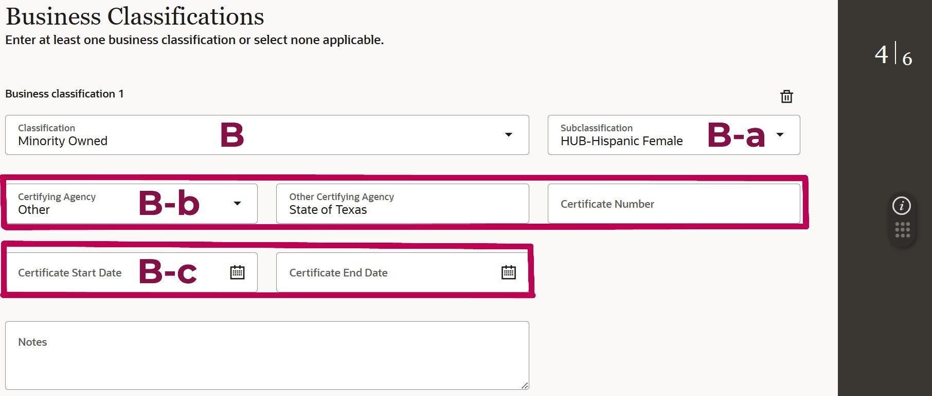
- If you are a Texas Certified HUB, select “Minority Owned” ONLY.
  - Choose the appropriate Subclassification category (ex: HUB-Woman Owned, HUB-Black Male, HUB-DV Female, etc).
  - Provide the certifying agency by selecting “Other” Certifying Agency and manually entering the Certifying Agency Name (ex: TX CPA).
  - Enter your HUB Certification Start Date and End Date.

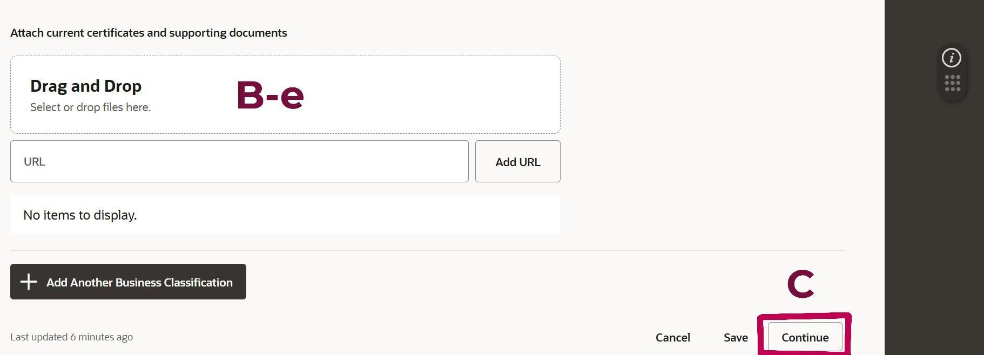
  - Attach your HUB Certificate via the Drag and Drop box.
- Do not add more than one Business Classification.
- Once complete, click “Continue”.

Bank Accounts [5 / 6]

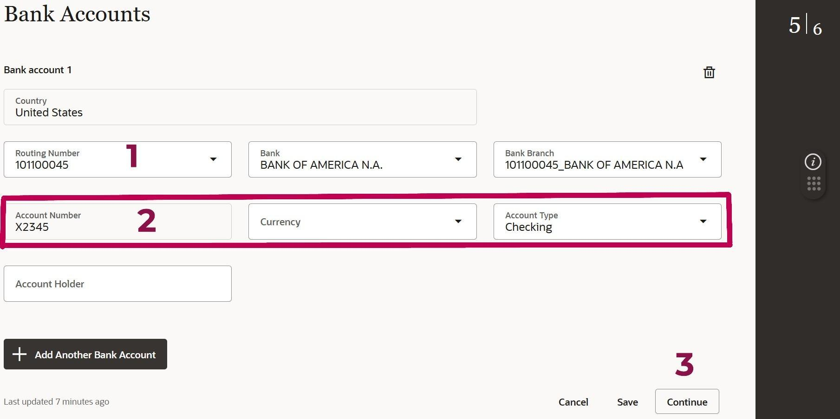

- Type in the Routing Number field. The Bank and Bank Branch will auto-populate.
  - If your routing number is not listed, contact TWUSupplier@twu.edu with your bank name and routing number.
- Enter the Account Number and select the Account Type.
- Once complete, click “Continue”.

Products and Services [6 / 6]

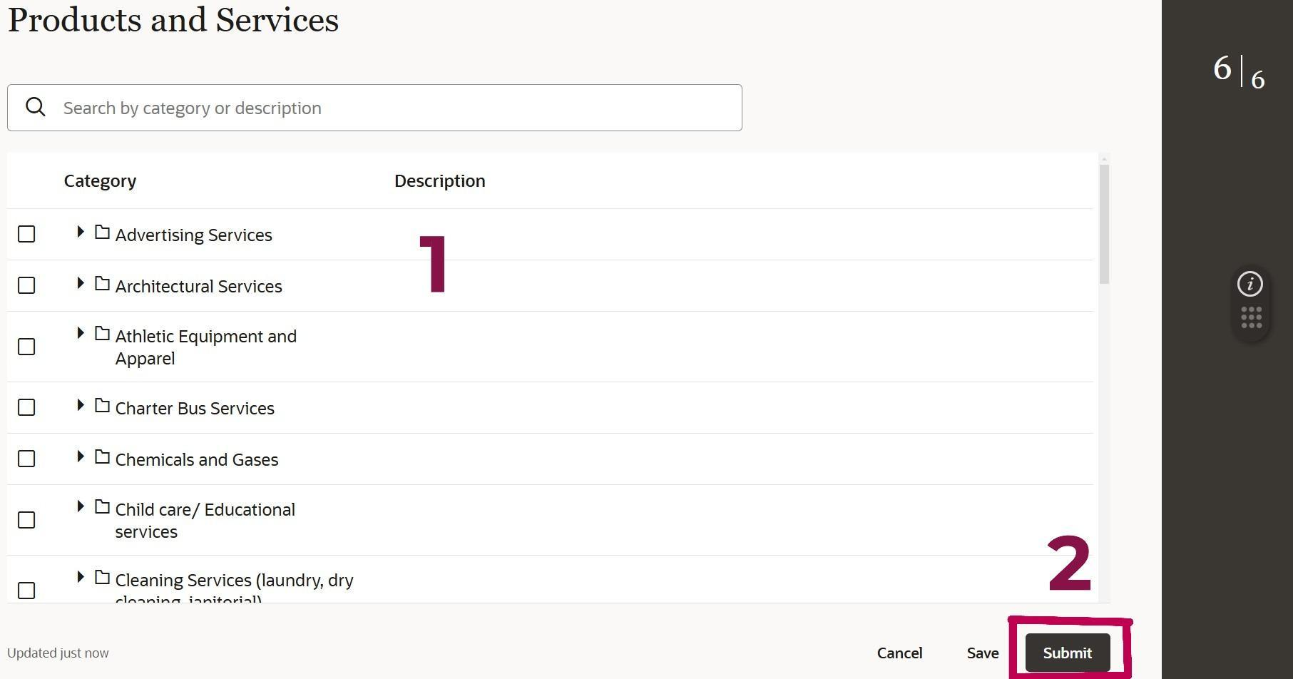

- Select all relevant categories that best represent your products and/or services.
  - Multiple categories can be selected or the category “Other” may be chosen if none are relevant.
- ***Click Submit to complete your registration***
  - Note: Clicking Submit is the only way to complete your registration. The Save button saves your progress, however your registration will be considered incomplete until you click “Submit.”

You’re all done!

Your request will be reviewed by Procurement and once approved, you will receive an email confirmation of your supplier profile.
Email TWUSupplier@twu.edu with any questions.

